

Blog Post Summary

10. Juni 2017

TEXTVENTURER

André Schmitt, Dominik Vogel, Simon Vollmer

Inhalt

PROJECT START 2

OUR TEAM 2

SOFTWARE REQUIREMENTS SPECIFICATION 3

USE CASE DIAGRAMM 4

YOUTRACK 4

TESTING SOFTWARE 4

CLASS-DIAGRAM (CRC) 5

SOFTWARE ARCHITECTURE 6

GANTT-CHART 6

MIDTERM SUMMARY 7

RISK MANAGEMENT 8

FUNCTION POINT CALCULATION 8

TEST PLAN 9

REFACTORING 9

METRICS 9

# PROJECT START

TextVenturer is, as the name implies, a Text-based Adventure.

We want to bring the retro game style of text adventures back to the present.

It will be possible to enter different scenarios, which you can discover alone or with friends.

These scenarios are saved as userfriendly readable scripts and we might add an even more easy-to-use editor for it, if we have enough time.

# OUR TEAM

Like we said before our team consists of three Students. Dominik Vogel, Simon Vollmer and André Schmitt.

AREAS OF RESPONSIBILITY:

|  |  |
| --- | --- |
| **Function** | **Name** |
| Implementation | Dominik Vogel, André Schmitt |
| Design | Simon Vollmer, André Schmitt, Dominik Vogel |
| Configuration Manager | André Schmitt |
| Tester | Simon Vollmer, André Schmitt, Dominik Vogel |
| Test Manager | Simon Vollmer |
| Project Management | Simon Vollmer, André Schmitt |

We are going to use the Programming Language C++ to write our program.

First we want to implement it as a Windows Desktop Application and if we have enough time we will get a website with our game running.

For an IDE we are going to use Visual Studio including a GitHub extension.

# SOFTWARE REQUIREMENTS SPECIFICATION

We want to keep you up to date.

Here is our newest version of our Software-Requirements-Specification.

You can look at it with the following link:  
<https://github.com/SchmittAndre/TextVenturer/blob/master/Software-Requirements-Specification.pdf>

Also, here is a UseCase-Diagram of the project:

[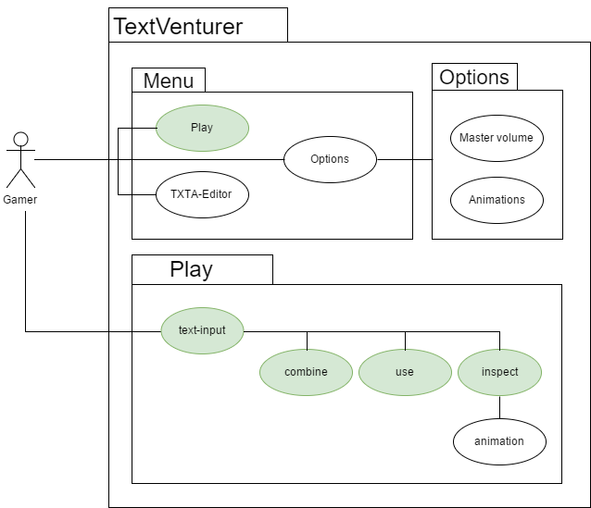](https://github.com/SchmittAndre/TextVenturer/blob/master/Use-Case-Diagramm.png)

# USE CASE DIAGRAMM

As you know for a Text-Adventure you need some rudimentary things like describing a [room](https://github.com/SchmittAndre/TextVenturer/blob/master/PAP/Enter_room.pdf), [combining things](https://github.com/SchmittAndre/TextVenturer/blob/master/PAP/combine.pdf), [use an Item](https://github.com/SchmittAndre/TextVenturer/blob/master/PAP/use.pdf), [pick up a Item](https://github.com/SchmittAndre/TextVenturer/blob/master/PAP/pick_up.pdf)or listing your current [inventory](https://github.com/SchmittAndre/TextVenturer/blob/master/PAP/get_inventory.pdf). So here are our Use Case Diagramms for these actions.

# YOUTRACK

If you want to stay up to date about our TextVenturer Project you can follow us on  ~~Jira~~. There you can see our status on what we have accomplished and all our open tasks.

edit:

Since we got problems with Jira we switched over to YouTrack. You can visit it [here](https://textventurer.myjetbrains.com/youtrack/dashboard?id=5d0dda45-ce23-4c54-a2b0-165f09cde144).

# TESTING SOFTWARE

Hey fans,

we tried to find a tool to auto test the game. After hours of searching our pro programmer Dominik Vogel just started to program a self-made testing tool.

And it works!

So now we will be even faster in finishing our project and u will soon be able to test our Alpha.

If you want to see his code you can see it here:

<https://github.com/SchmittAndre/TextVenturer/tree/master/InputSiumlator>

Greetings TextVenturer

# CLASS-DIAGRAM (CRC)

Hey fans,

we finally got our Class-Diagram. Since we created it with VisualStudio it went without any major problems.

Now you can see how our classes work together in this awesome looking diagram.

[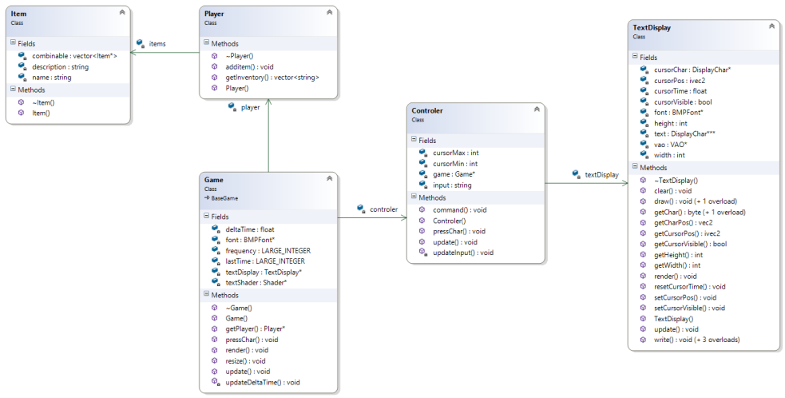](https://textventurer.files.wordpress.com/2016/11/classdiagram.png)

Greetings

TextVenturer-Team

# SOFTWARE ARCHITECTURE

Hey Guys,

today we want to present you our Software architecture.

You may see it [here](https://github.com/SchmittAndre/TextVenturer/blob/master/Softwarearchitecture.pdf).

Greetings TextVenturer

# GANTT-CHART

Hey Guys,

today we want to show you our Gantt Diagram.

Big thanks to Project VNV. Without your parser we never would’ve gotten this chart to work.

[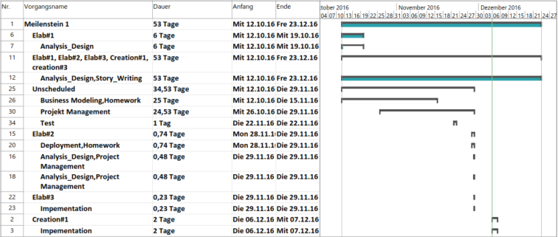](https://textventurer.files.wordpress.com/2016/12/gant-diagramm.png)Gantt-Chart 6.12.16

Greetings TextVenturer

# MIDTERM SUMMARY

Hey Fans,

we are already halftime through and we want to show you a quick summary of what we have done so far.

Project Vision: <https://textventurer.wordpress.com/2016/10/12/project-start/>

GitHub Repo: <https://github.com/SchmittAndre/TextVenturer>

Project Management: <https://textventurer.wordpress.com/2016/10/18/our-team/>

Use Cases: <https://textventurer.wordpress.com/2016/10/30/use-case-diagramm/>

Software Requirement Specifications: <https://github.com/SchmittAndre/TextVenturer/blob/master/Software-Requirements-Specification.pdf>

Test Cases: <https://github.com/SchmittAndre/TextVenturer/tree/master/InputSiumlator/scripts>

Our Testing Tool: <https://textventurer.wordpress.com/2016/11/15/testing-software/>

Gannt Chart: <https://textventurer.wordpress.com/2016/12/06/gantt-chart/>

Burndown-Diagramms: [YouTrack](https://textventurer.myjetbrains.com/youtrack/dashboard?id=5d0dda45-ce23-4c54-a2b0-165f09cde144)

Demo download: <https://github.com/SchmittAndre/TextVenturer/releases>

Code View:  <https://github.com/SchmittAndre/TextVenturer/tree/master/SoftwareEngineering>

Software Architecture: <https://github.com/SchmittAndre/TextVenturer/blob/master/Softwarearchitecture.docx>

Environmental Setup: We used VisualStudio as our IDE for our C++ programm. For visualising we used OpenGL and our Testing Tool is written in Lazarus.

Automated testing: Coming soon!

Presentation: Coming soon!

# RISK MANAGEMENT

Because our Projekt and Teamwork pose various risks, we had to analyse and rank those risks.  
Therefore, we compiled a list of our top 5 risks:

# 

# FUNCTION POINT CALCULATION

Today we’re going to show you how we tried to predict the future using Function-Points. We want to know, how long it would probably take to implement a new feature into our Game. To do this, we rated all our old modules and calculated the so called Function-Points for it using this website: [TINY TOOLS](http://groups.engin.umd.umich.edu/CIS/course.des/cis525/js/f00/harvey/FP_Calc.html)

With the results, we can then draw an averaged line, so we can simply read off the required time for new modules. Obviously this is only an estimation, and there might be a big margin, but it still gives a rough idea of how much time a specific module will take up.

[Function Points Calculation](https://github.com/SchmittAndre/TextVenturer/blob/master/FP-Prediction.xlsx)

# TEST PLAN

For a software, to be bug-free, is very important. Therefore we concluded all the aspects of our testing in the following document:

[Test Plan](https://github.com/SchmittAndre/TextVenturer/blob/master/Documentation/TestPlan.pdf)

We want to make sure, that our users don’t stumble upon bug after bug, killing all the fun of the game.

Our testing consists of two parts.

Normal UnitTests, which ensure, that our classes and their respective functions work flawless

Input Simulator, to test, if the adventures, writtien in the TextVenturer-Scripting language, can be completed with the correct inputs

# REFACTORING

The last week we tried to refactor an example-project as practice. You can see our results at our individual git repos:  
[Andre](https://github.com/SchmittAndre/SE2_05_Refactoring)[Dominik](https://github.com/Possseidon/Fowler)[Simon](https://github.com/remllov91/SE_Refactoring)

# METRICS

During the course of the last week we worked on metrics. [Here](http://h2688162.stratoserver.net:8080/www/CppDependReport.html#Main)you can see our first analysis.  
As you can see, we worked with “[CppDepend](http://www.cppdepend.com/)“, which is an easy to use code analysis tool. It is unfortunately only a trial though and cost a fairly great amount of money, in case we want to keep using it. There aren’t many alternatives, and all of them are also paid.

The generated [TreeMap](http://h2688162.stratoserver.net:8080/www/NDependReportFiles/VisualNDependView.png)shows, that a lot of problems are coming from the loadpng header. That header is not written by ourselves, and we therefore won’t change anything major in it. We need it, as the named reveals, to load the font, which is saved as PNG.

The only really “critical” problems are a few long functions, which had their reasoning, but might eventually get changed around, when we have time for it and decide to do so.